Plan:

Conduct and include model comparisons:

Find means and SDs for panel items

Filler stats? Nope, nema xD

Find best parsimonious model by taking out non-significant predictors

13 out of 960 trial loss

The frequency for English words ranges from 0.69 to 6.08 log natural transformed frequency counts, whereas the Spanish word frequency ranges from 0.6 to 7.58 counts.

(English counterpart low frequency group range: 0.693-2.303; Spanish counterpart low frequency group range: 0.602-2.303; English counterpart high frequency group range: 3.989-7.396; Spanish counterpart high frequency range: 4.007-7.584.)

Participant intercept and Language Context and FreqFix slopes were included in the model as random effects. None of the main effects was found to significantly affect the dependent variable. Nevertheless, the Language Context X FreqFix interaction was significant, β = 0.487, SE = 0.237, t = 2.051, such that participants were looking at the low frequency item in the CS condition more than in the Spanish condition (Table X……). Graph X ……………. shows the data predicted by the model (line) vs. observed data (points).

Z-scored proportions of time spent looking at a set of items in a particular condition in each bin was fit to a linear mixed-effects model using lme4 package in R (Bates et al., 2011) with the independent variables Language (contrast coded as Spanish -0.5, Code-switched +0.5), Frequency of the Fixated Item (FreqFix; contrast coded as High -0.5, Low +0.5), and Language Dominance (continuous), as well as their interactions, as predictors. Participant Language Context and FreqFix intercepts were included in the model as random effects. The model with Participant Language and FreqFix slopes failed to converge. The main effect of Language was found to be significant, such that there were more looks in the Spanish condition compared to CS. Importantly, the Language X FreqFix interaction was significant, β = 0.489, SE = 0.048127, t = 2.051, such that participants were looking at the low frequency item in the CS condition more than in the Spanish condition (Table X……). Graph X ……………. shows the data predicted by the model (line) vs. observed data (points).

Z-scored proportions of time spent looking at a set of items in a particular condition in each bin was fit to a linear mixed-effects model using lme4 package in R (Bates et al., 2011) with the independent variables Language (contrast coded as Spanish -0.5, Code-switched +0.5), FreqFix (contrast coded as High -0.5, Low +0.5), and Dominance (continuous), as well as their interactions, as predictors. **The time variable transformed using orthogonal polynomials, OT1, OT2, OT3, were also included in the model, as well as their interactions with the three aforementioned variables. Participant** **Language, FreqFix, and orthogonal polynomial terms intercepts were included in the model as random effects.**

**Results of the analysis are summarized in the Table X ……………**

**Only OT1 main effect was found to be significant, β** = 0.2849608, **SE =** 0.095**,t =** 2.990, **such that overall looks increased over time. Importantly, several interactions were found to be significant (Table X……….). The** Language x FreqFix **interaction proved significant,** **β** **= 0.492, SE = 0.047, , t= 10.374, such that Low frequency items were fixated more in the CS condition compared to Spanish condition. Also, the interaction of** Language, Dominance, and FreqFix **was significant, β** **= 0.287, SE = 0.047, t = 6.066, such that** **the participants with higher relative Spanish dominance looked at the Low frequency items more in the CS condition compared to Spanish condition. This interaction was driven by the higher Spanish-dominance speakers looking at the Low frequency item less in the Spanish condition. The interaction of** Language, FreqFix, and the 1st order orthogonal polynomial term **was also found to be significant, β = 0.891, SE = 0.211, t = 4.218 such that the looks towards the Low frequency item increased over time in the CS condition compared to Spanish condition. The interaction of** Language, Dominance, FreqFix, and 1st order polynomial term was significant as well, β = 0**.820, SE = 0.211,** t = **3.883, such that the participants with higher relative Spanish dominance looked more over time at the Low frequency item in the CS condition compared to the Spanish condition. Graph X ………… shows the model fit, with modeled data represented as lines and observed as points. Graph X ………….. shows the residuals from the model. Residuals seem to be normally distributed and do not show traces of autocorrelation. This is confirmed by the normal distribution (straight line) in the Q-Q plot (Graph X……….).**

**A backwards stepwise model regression ……….. found that the 4-way interaction of Language x Dominance x FreqFix x OT1 significantly improved the model, p(Chi) = 0.000103, corroborating the results of the Growth Curve Analysis model. To create the most parsimonious model, we removed the orthogonal polynomial terms OT2 and OT3 since they were not significantly contributing to the model……………. The results of this model are summarized in Graph X………..**

Figure 1……………. below is a histogram representing the distribution of the target picture name frequencies in all lists. There is a marked gap between the frequencies of the two groups, ensuring that the research design includes the desired manipulation.

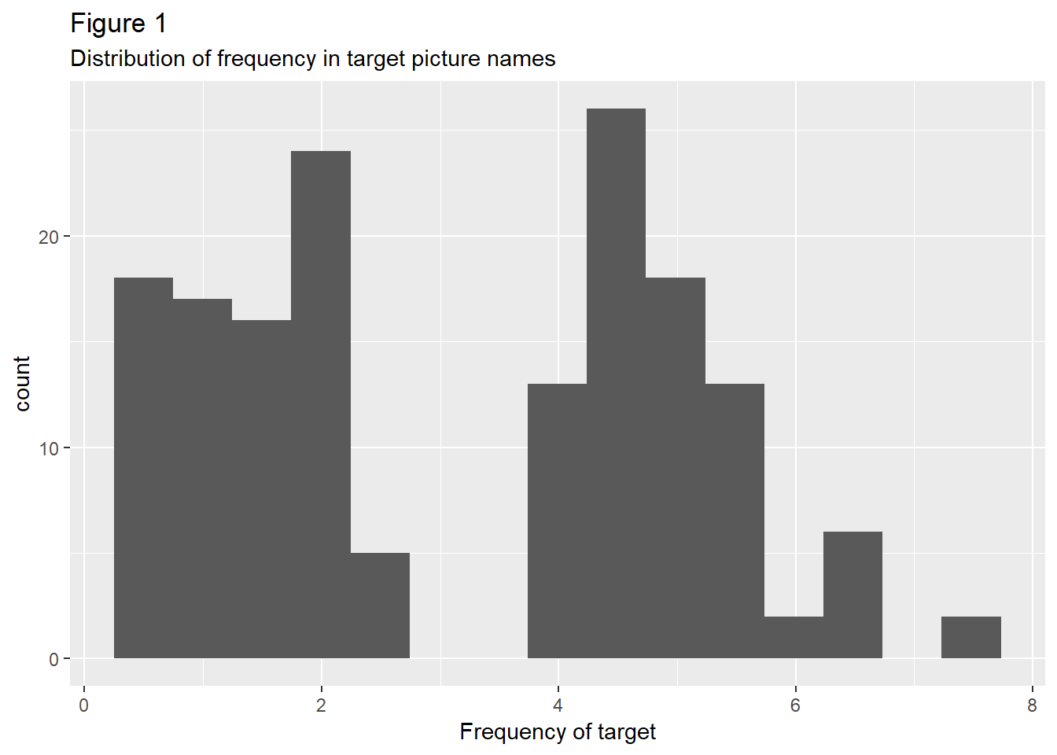

In addition to being paired for the maximum frequency difference between low and high frequency member pairs, as well as for the maximum frequency similarity between Spanish and English picture name counterparts,

**Only target looks for basic model with participants random and participants+items random**

**And ortho poly**

**Items as thingies random effects – nope, the total looks are then just 20 ms, cause each item in a set of items in the same condition has a different pair number, so the proportion is like 15 looks to target out of 20, the props are then showing per each individual item, per each individual bin**

**Both as random effects?**

**Do the items as random thingies in CS-aids-prediction**

**CS as a freaking variable**

How did I do it right the first time?

N-k-1 = df

4757 = N

k = number of variables in the model

Reml was true here, but what if it should be false?

I’ve done it once like a pro, I’ll do it again.

Allopenna P.D., Magnuson J.S., Tanenhaus M.K. Tracking the time course of spoken word recognition using eye movements: Evidence for continuous mapping models. Journal of Memory and Language. 1998;38(4):419–439

One advantage of mixed models compared to traditional repeated-measures ANOVA is that we’re explicitly calcuating a regression model. As such, we have an individual estimate for each interaction as part of our model summary. We do not have to resolve interactions explictly, we can instead simply look at the individual interaction levels in the coefficients.

Stimuli:

Start with the same letter?

Cutting and intensity scaling?

Participants:

Age 18-32 (M = 20.83, SD = 3.53)

Gender (26 female, 4 male)

Age of acquisition of Spanish and English

**Proficiency – dominance**

**Graphical dominance but continuous variable**

Introduction and Background

Nevertheless, studies have found that there is a cost associated with its processing (Altarriba et al., 1996; Meuter & Allport, 1999), albeit reduced with the increase in experiments’ ecological validity (Blanco-Elorrieta & Pylkkänen, 2017). This seeming contradiction between the ubiquity of code-switching and the associated processing costs has not found a clear explanation in the current psycholinguistic research on the online processing of CS.

Nevertheless, offline psycholinguistic studies and sociolinguistic observations offer converging socio-pragmatic and information-organizational motivations for CS. These motivations might outweigh any purported costs of processing for bilinguals and solidify the use of CS as a discourse marker.